# **P3: Implementation**

Streaming Service Analysis

Team 6

Abhishek Tikam Ramchandani – 002743745

Jurreyah Firdaws Mohammed – 002747514

Atharva Uplenchwar – 002990536

Samhitha Mereddy – 002796140

**Implementation Process:**

1. ERD

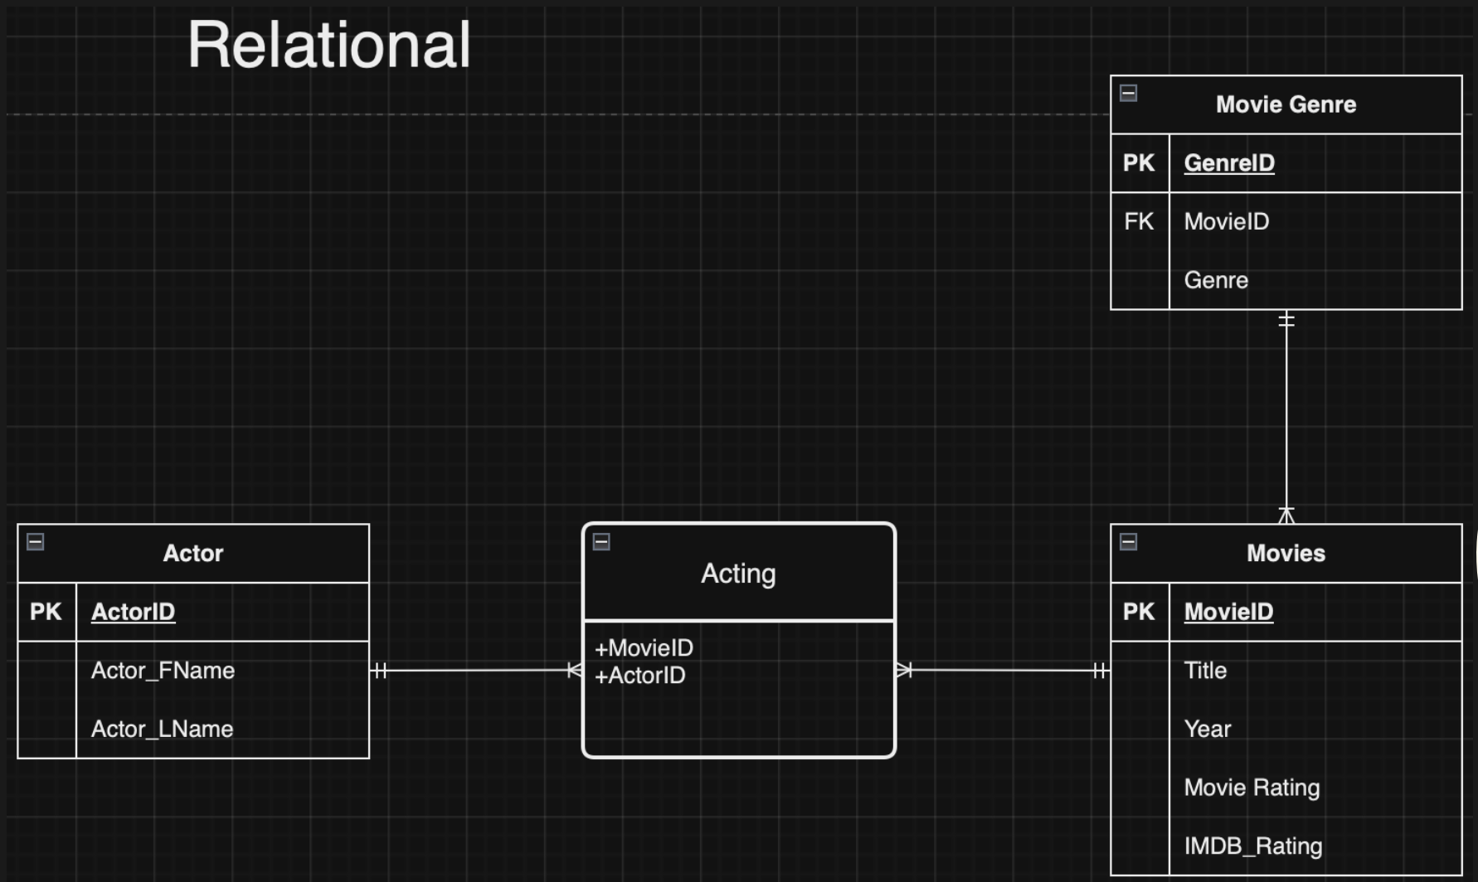

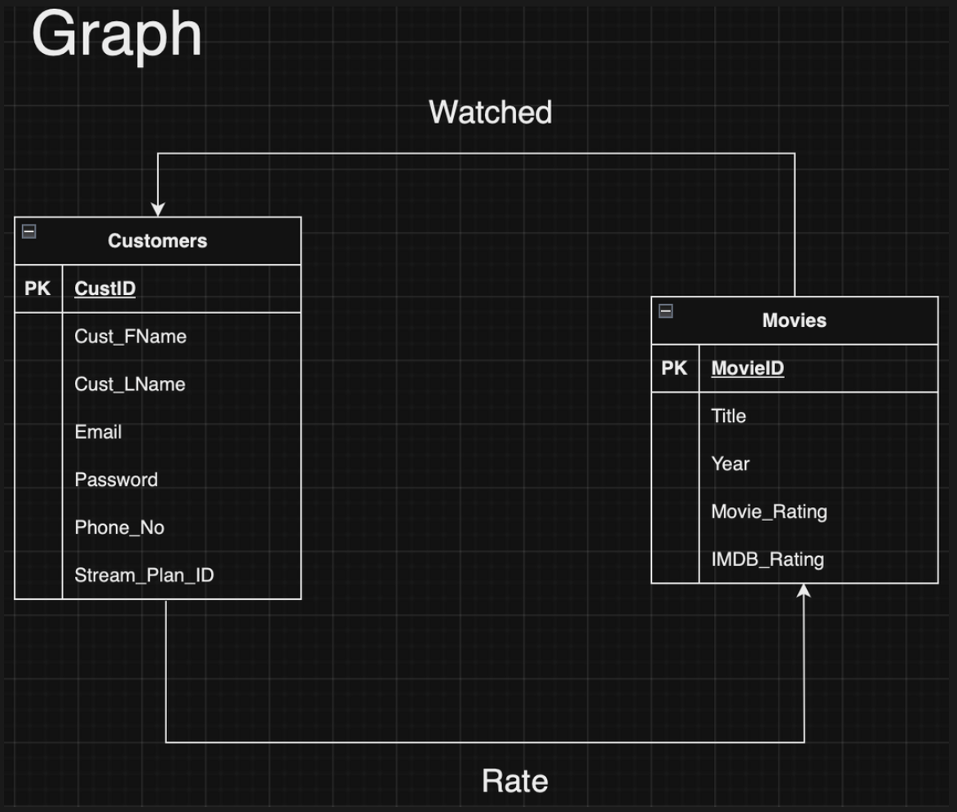

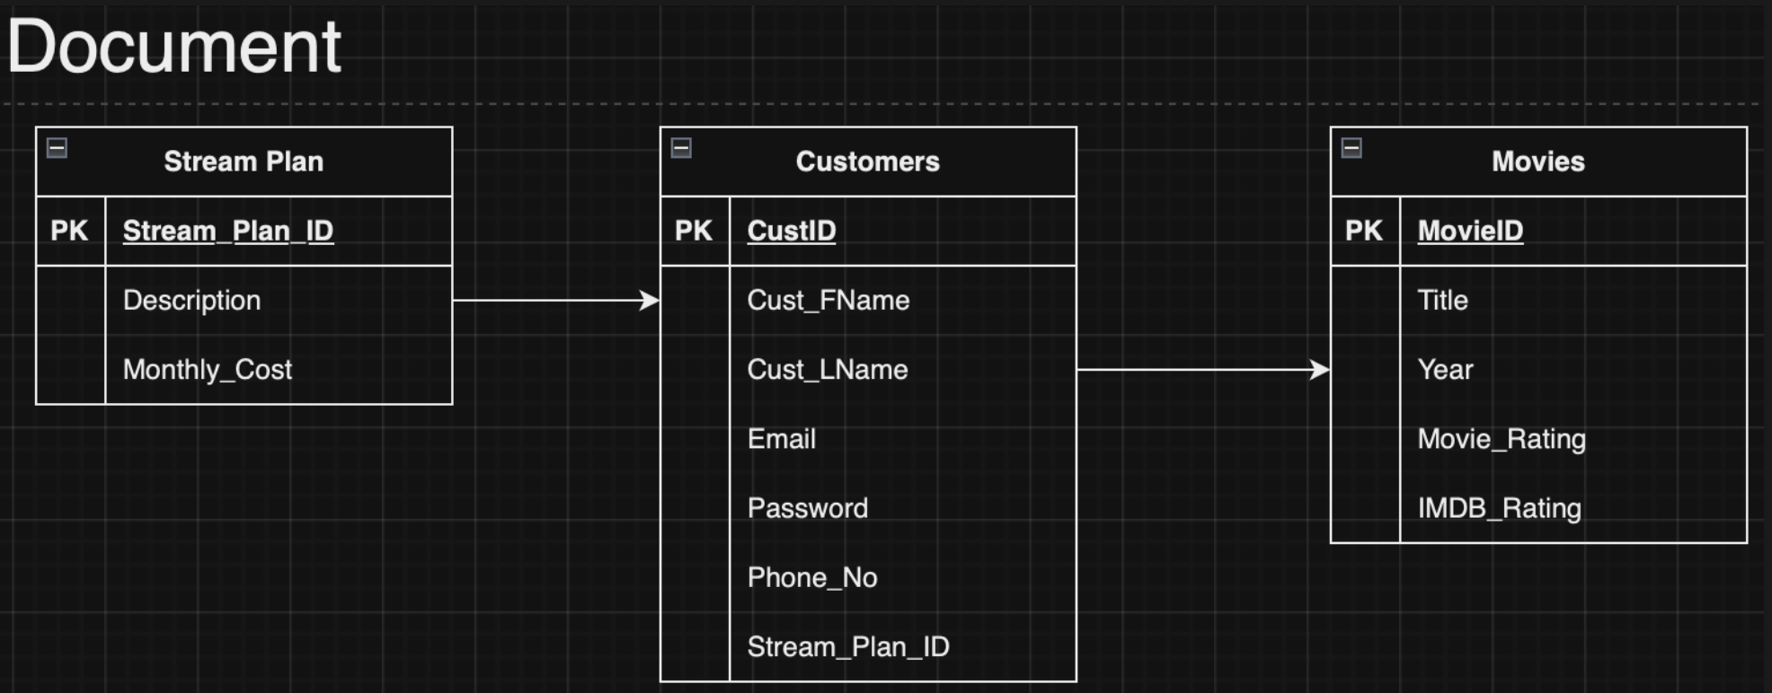

1. Objective

The goal of this document is to outline the process for implementing a relational database system based on an Entity-Relationship Diagram (ERD) provided by the client. The document covers the creation of SQL queries for table generation, Alteryx workflow for data processing, and data cleaning techniques used throughout the process.

1. SQL Table Creation:

Actors Table: A straightforward table holding actors' data, uniquely identified by ActorID.

Movies Table: Contains details of movies, including a unique identifier MovieID.

Acting Table: Serves as a junction between Actors and Movies, featuring a composite key.

Movie Genre Table: Connects genres to movies, identified by GenreID.

Customers Table: Stores customer information, each associated with a Stream_Plan.

Stream Plan Table: Describes streaming plans available to customers.

The SQL statements were exactly created to ensure referential integrity and to encapsulate the many-to-many relationships between entities.

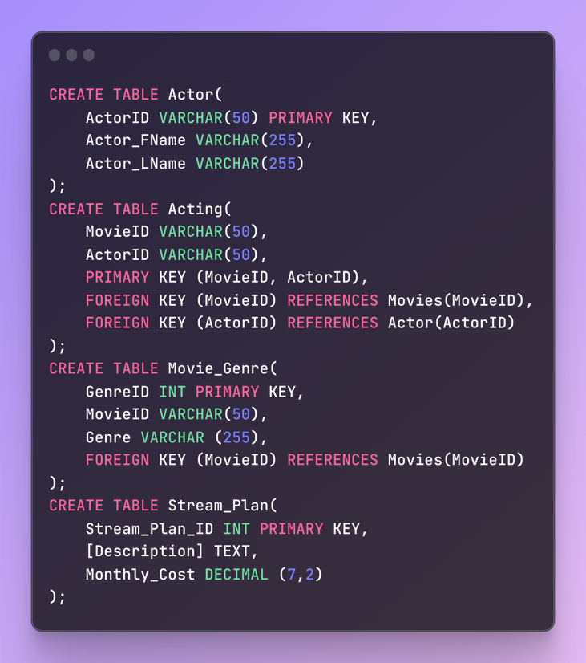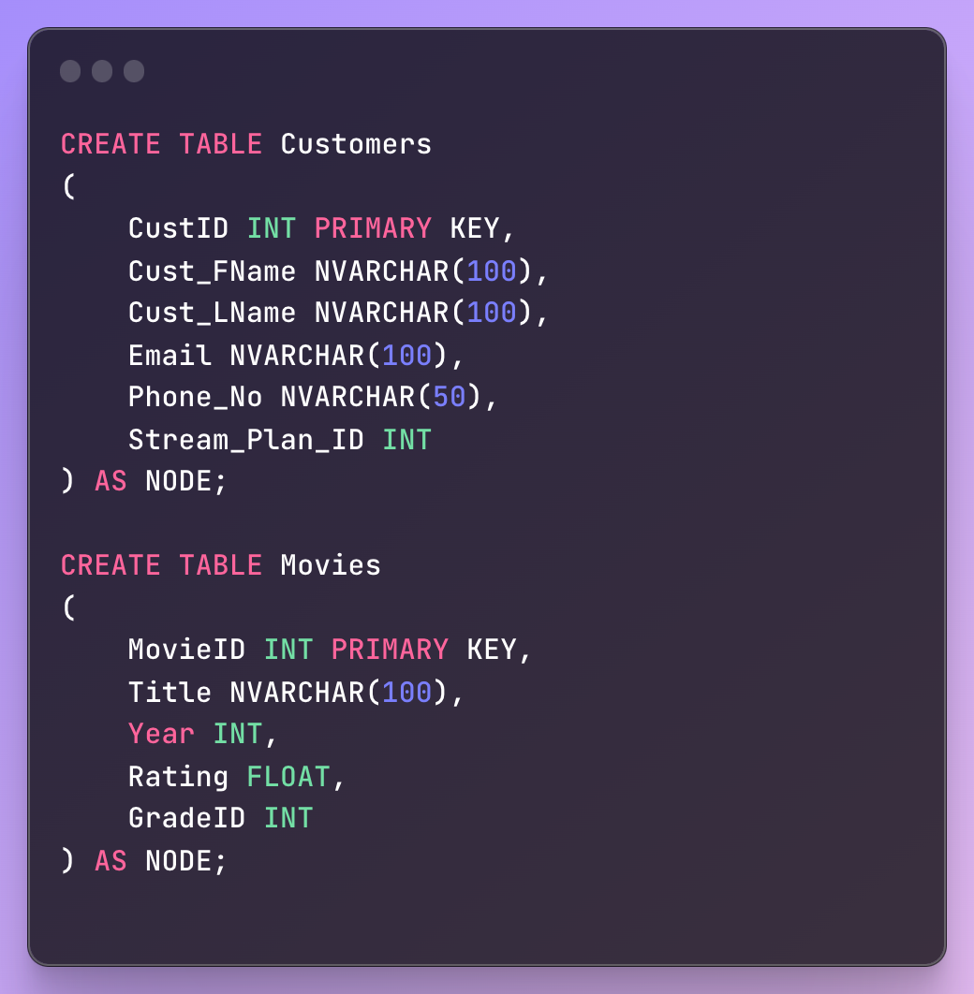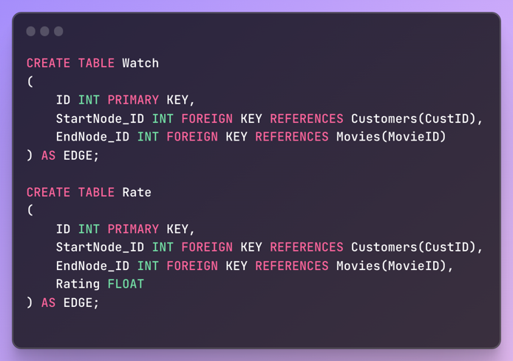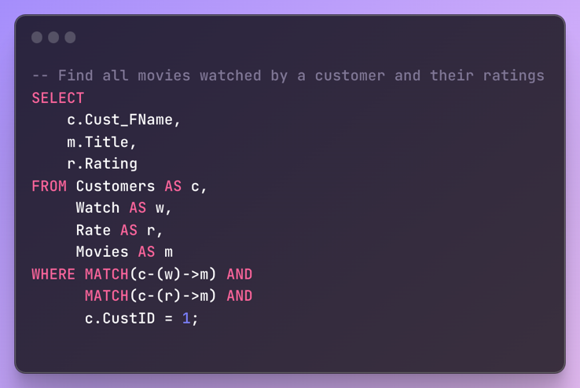

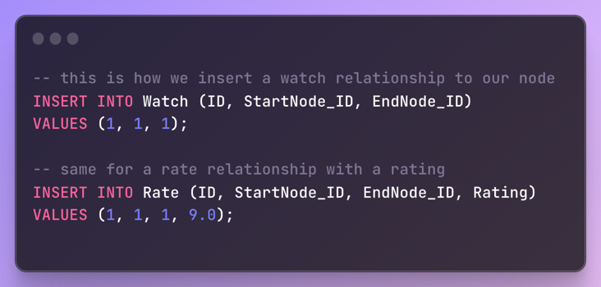

Document model:

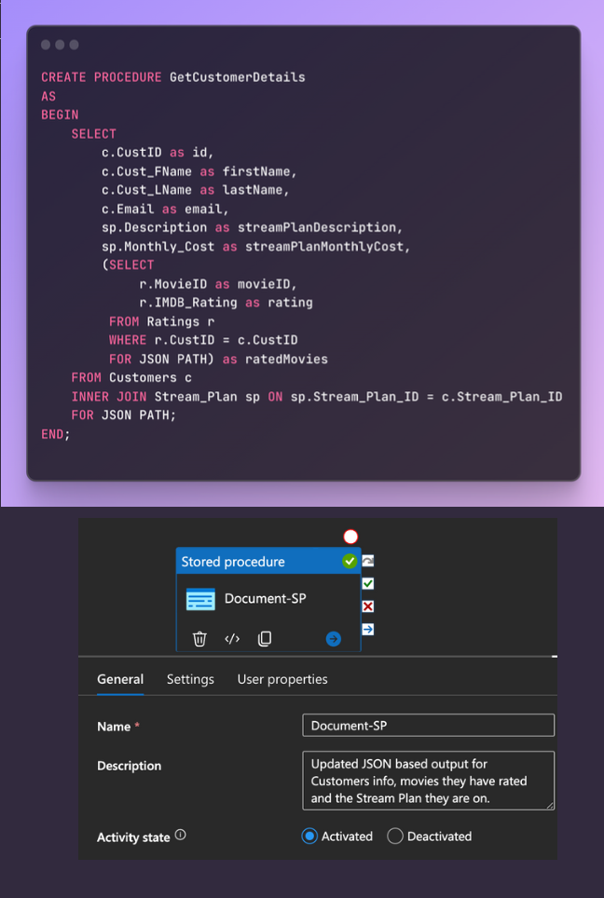

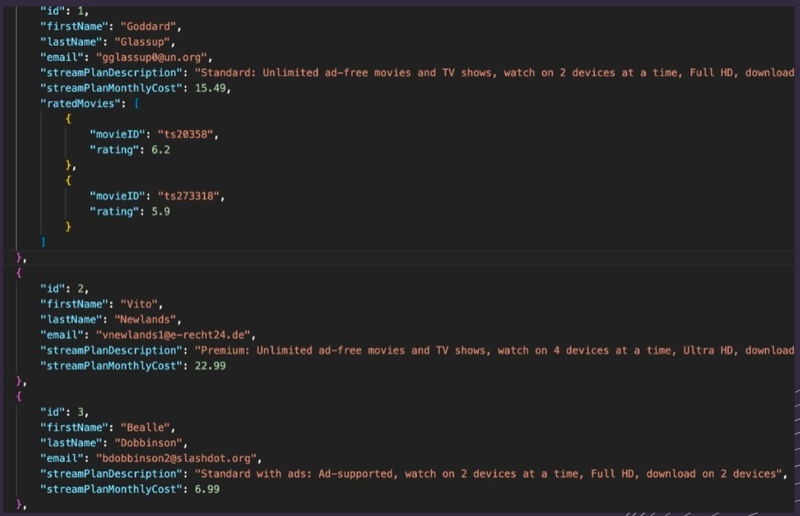

1. Alteryx Data Processing:

This was the original acquired dataset before any preprocessing or cleaning -

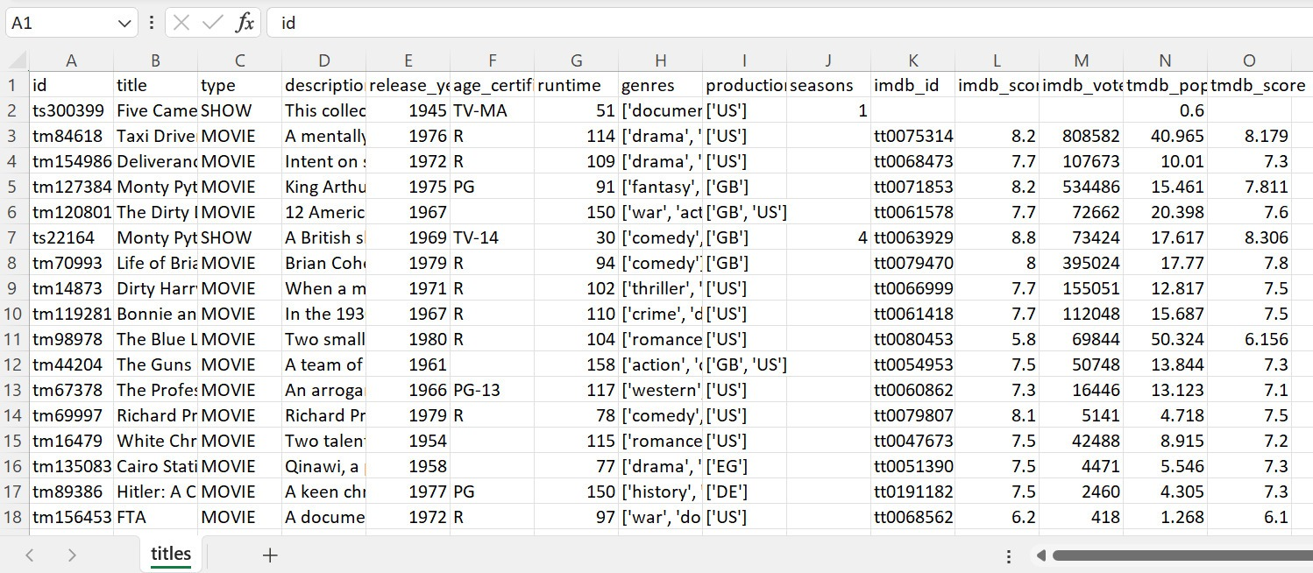

Input Data: The Alteryx workflow initiated with data ingestion from various sources.

Data Splitting: Using the Text-To-Columns tool, we parsed composite fields into discrete data points.

Data Cleansing: We employed the Data Cleansing tool to strip extraneous characters and whitespace, ensuring a pristine dataset.

Formula Tool: Applied conditional logic to replace null values in the dataset with default values or specific text, fortifying data integrity.

1. Data Cleaning and Processing:

Null Value Treatment: Null entries in "IMDB Rating" were populated with a default score to maintain consistency.

Name Segmentation: Customer names were segmented into first and last names to enhance personalization and targeting.

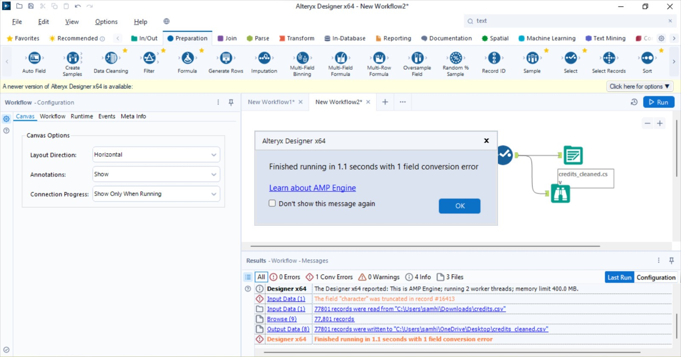

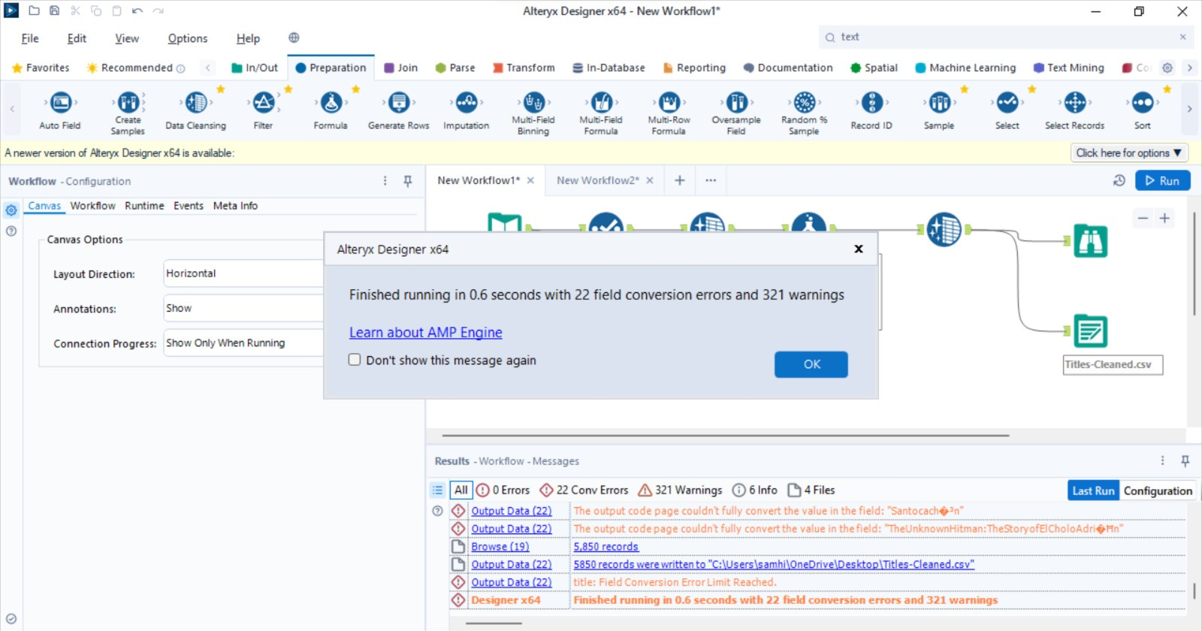

We generated the data for a random customer user-base using Mockaroo.

Following that, we used Alteryx again for Data Manipulation and Cleaning.

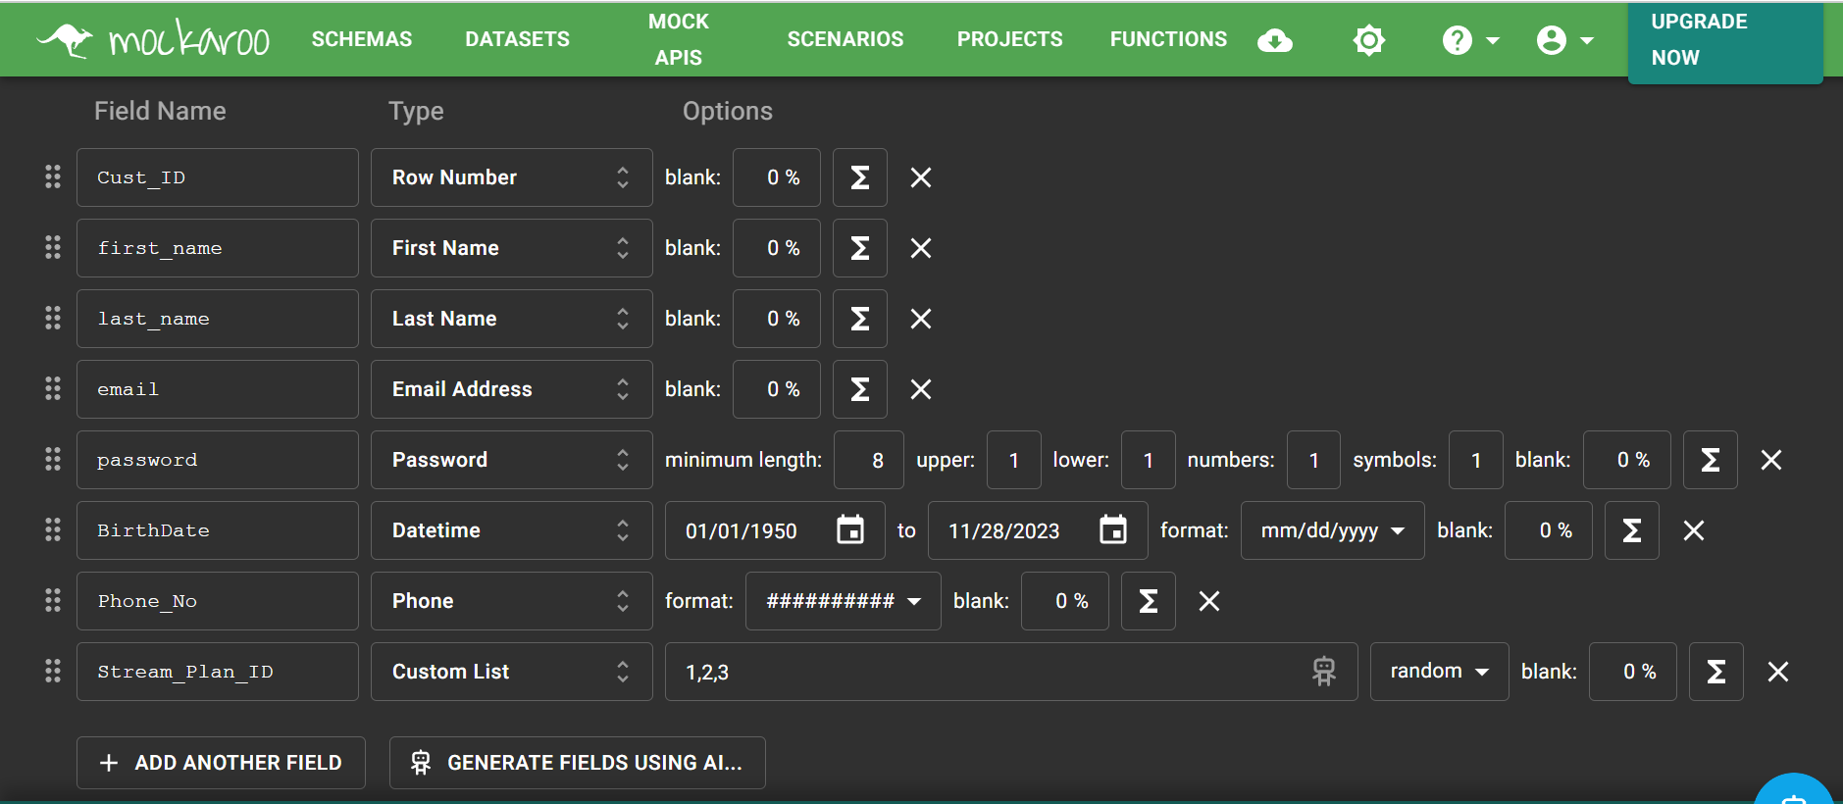

All the null values in the title column were deleted.

Then for the IMDB ratings, wherever the rating was missing, we added a generalized rating (7.0).

Further, since the acquired dataset had multiple genres under one movie, we limited it to 1 genre per movie for the sake of simplicity.

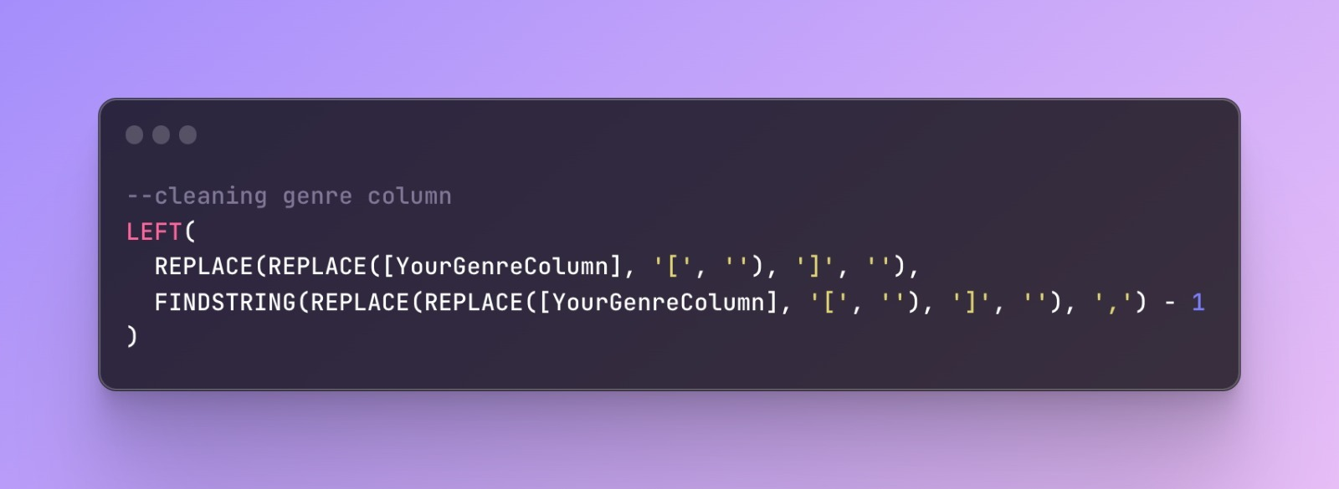

The null values under the movie rating were given ‘PG-13’. Finally, we dropped all the columns we wouldn’t be using.

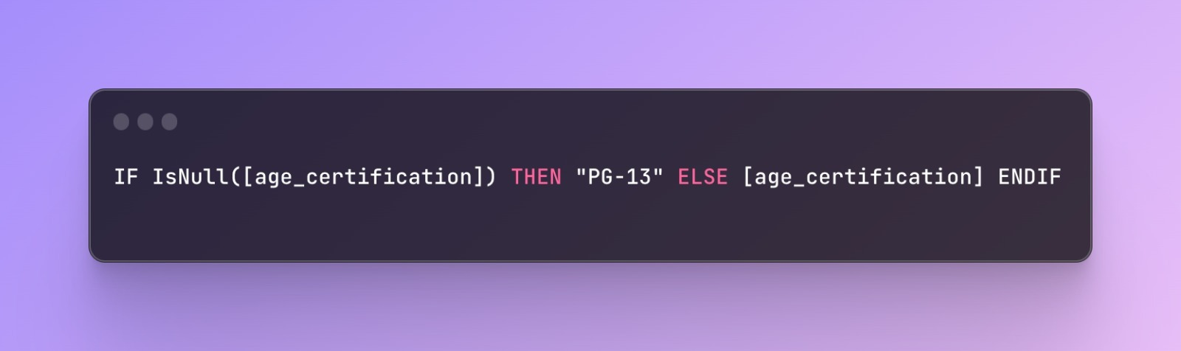

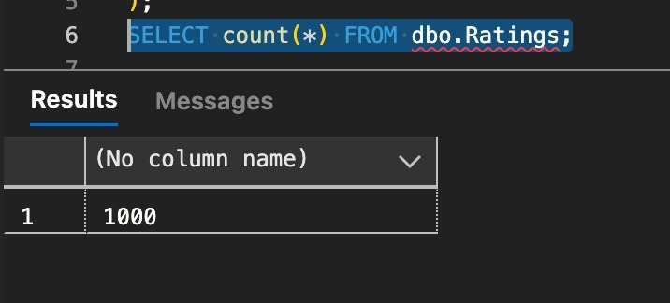

Ratings for all the movies have been successfully imported.

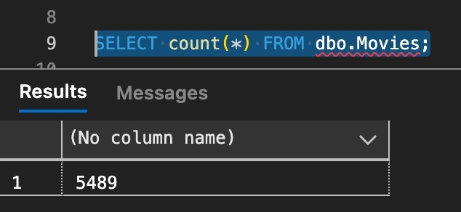

All the movies have been successfully imported via Azure Data Factory.

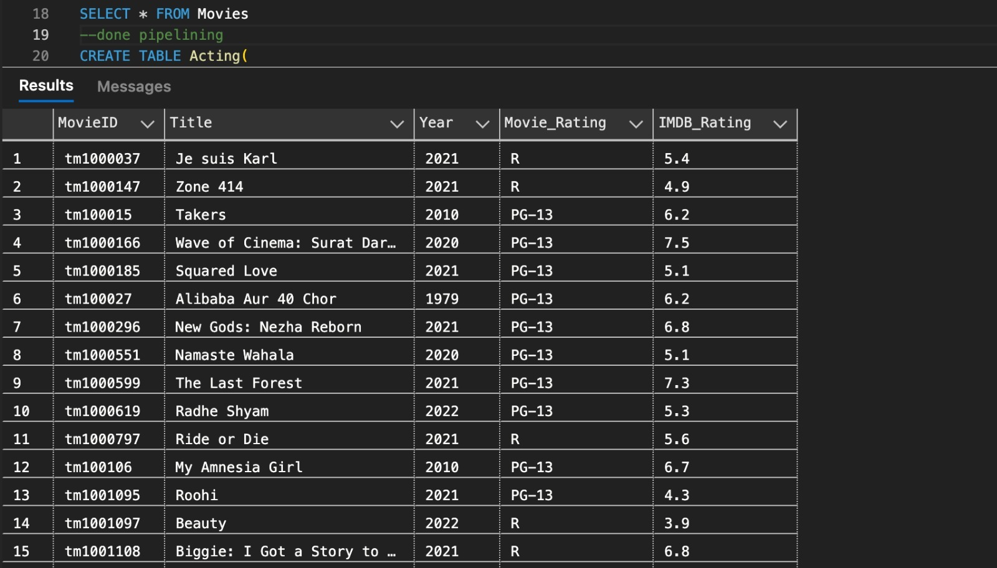

Proof of the movies data being successfully imported.

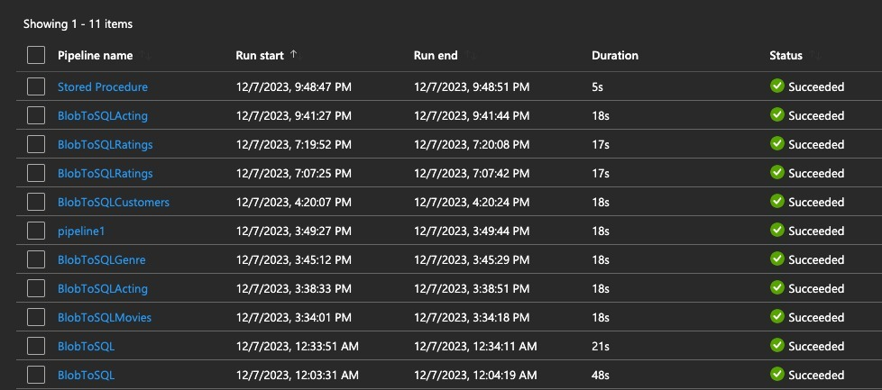

In a similar manner, all the tables were successfully imported.

Implementation of the graph database through Neo4j:

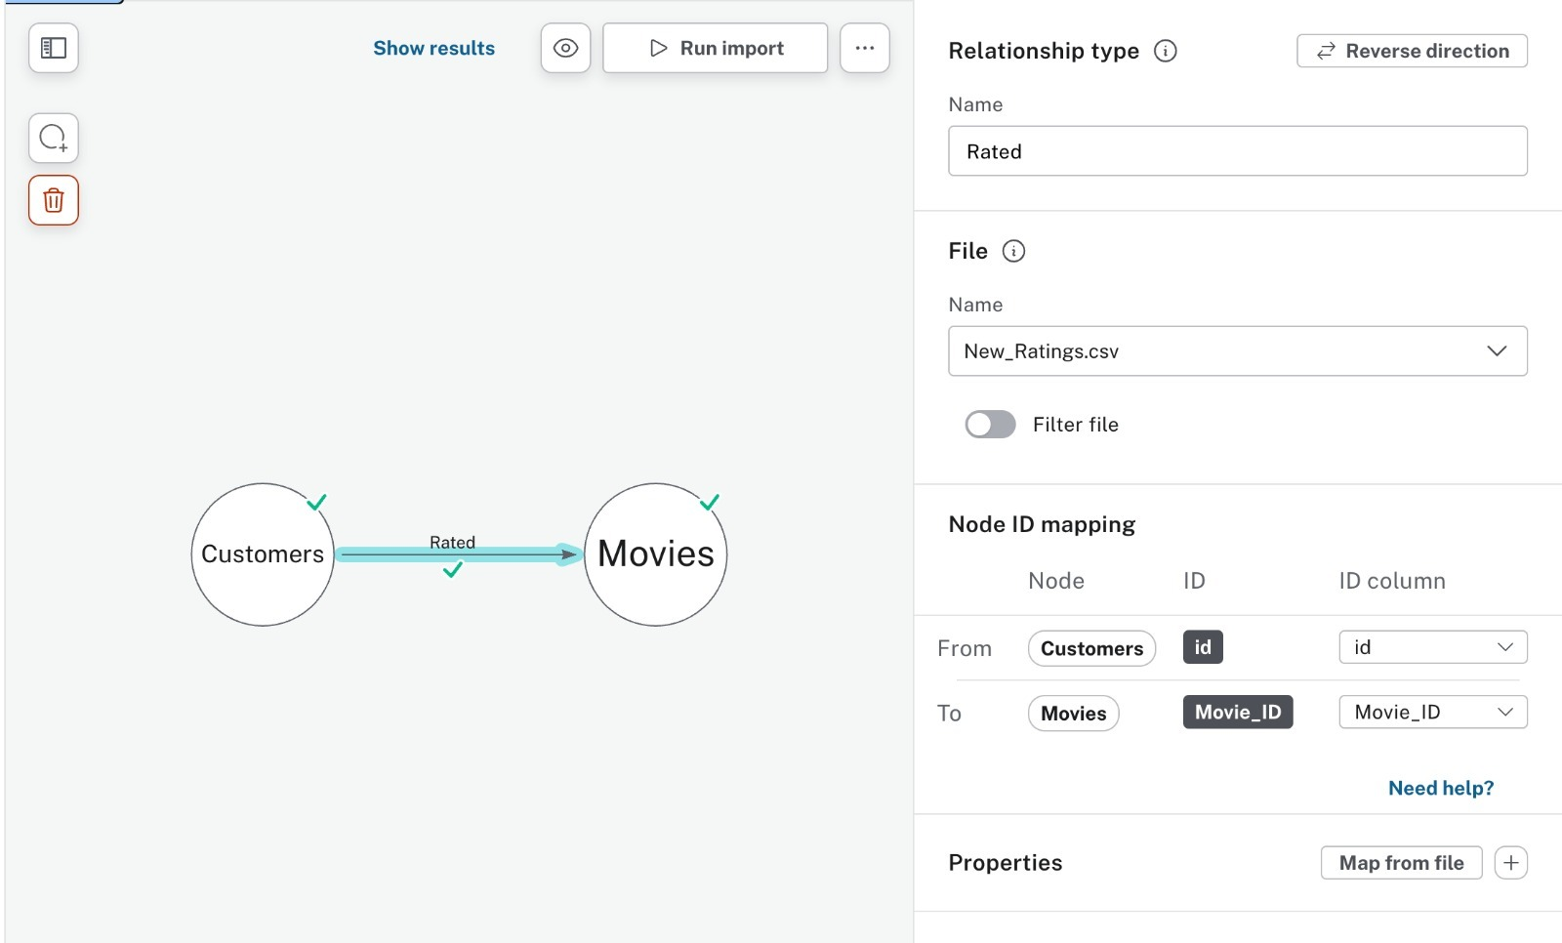

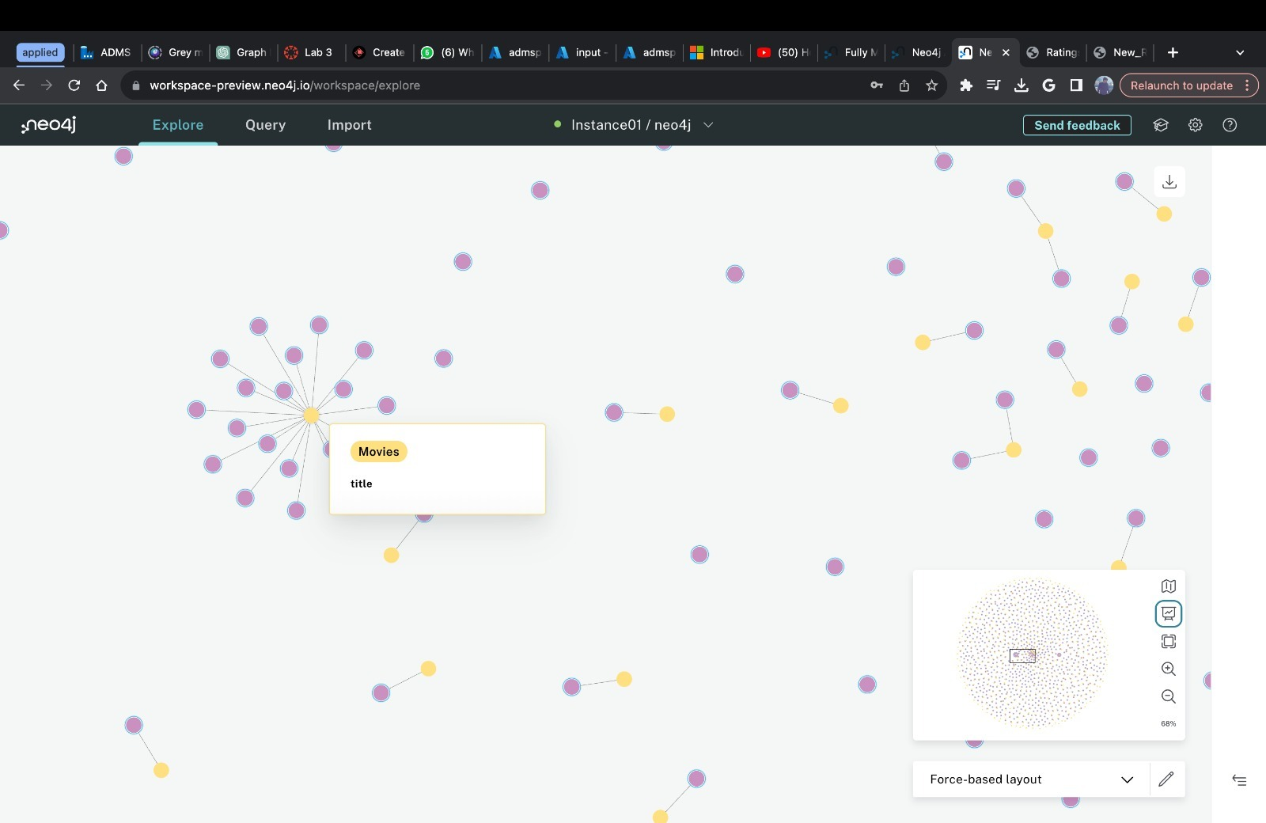

The yellow circles are movies, and the pink circles are customers. This graph model shows that customers rate movies. In some cases, multiple customers have rated a single movie as can be seen in the picture. As the data from the customer ratings keep increasing, the ratings per movie will also increase.